

DEPARTMENT OF MATHEMATICS

ACADEMIC YEAR 2017 to 2024



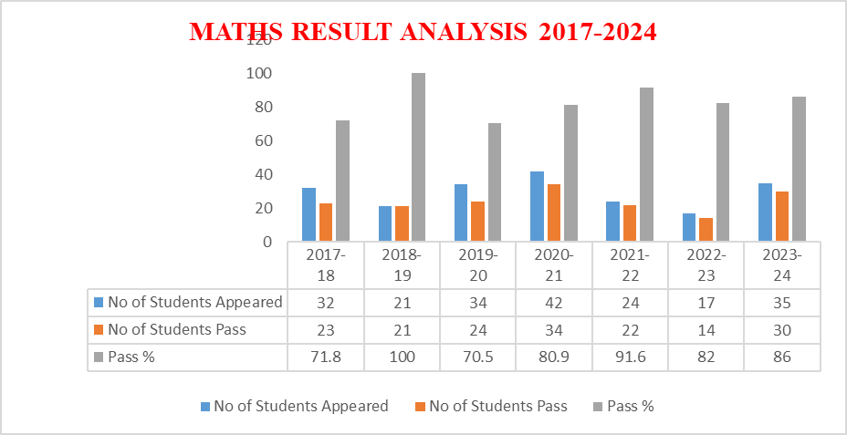

DEPARTMENT OF MATHEMATICS

Result analysis of B. Sc (Physics) & B. Sc (MPC) 2023-24

SEM | Paper | Name of the paper taught | No. Of passed in the following Grade |  |  |  |  |  |  | No. of Students Attended | No. of Students Passed | Pass percentage
SEM | Paper | Name of the paper taught | O | A+ | A | B+ | B | C | P | No. of Students Attended | No. of Students Passed | Pass percentage
I | Peper-I | Essentials of Mathematical, Physical and Chemical sciences |  |  |  | 3 |  |  | 1 | 5 | 4 | 80
I | Peper-II | Advances in Mathematical, Physical and Chemical sciences |  | 3 | 1 |  | 1 |  |  | 5 | 5 | 100
II | Paper-III | Differential Equations |  | 1 | 2 | 2 |  |  |  | 5 | 5 | 100
III | Peper-III | Abstract Algebra |  |  |  |  | 1 |  |  | 2 | 1 | 50
IV | Paper -IV | Real Analysis |  |  |  | 1 |  |  |  | 2 | 1 | 50
IV | Paper- V | Ring Theory |  |  |  |  |  | 2 |  | 2 | 2 | 100
V | Paper- 6C | Linear Algebra |  |  | 2 | 1 |  | 2 |  | 5 | 4 | 80
V | Paper- 7C | Laplace Transforms |  |  |  |  |  |  |  | 4 | 3 | 75
VI | Long-term Internship |  |  |  | 1 | 2 |  | 2 |  | 5 | 5 | 100
No.of Physics Students in all semesters |  |  |  |  |  |  |  |  |  | 35 | 30 | 92.68

ANALYSIS: The performance of the students of III semester in Abstract Algebra was less compared to other semesters and other subjects
ACTION TAKEN: Extra classes and separate materials are to be given to the students who performed less in the Abstract Algebra paper of III semester so that their performance is to be improved.
DEPARTMENT OF MATHEMATICS
Result analysis of B. Sc (MPC) 2022-23

SEM | Paper | Name of the paper taught | No. Of passed in the following Grade |  |  |  |  |  |  | No. of Students Attended | No. of Students Passed | Pass percentage
SEM | Paper | Name of the paper taught | O | A+ | A | B+ | B | C | P | No. of Students Attended | No. of Students Passed | Pass percentage
I | Peper-I | Mechanics and Wave & Oscillations |  |  |  |  |  | 2 |  | 6 | 3 | 50
II | Paper-II | Wave Optics |  | 1 |  |  |  |  |  | 1 | 1 | 100
III | Peper-III | Heat and Thermodynamics |  | 1 |  |  |  |  | 1 | 2 | 2 | 100
IV | Paper -IV | Electricity, Magnetism& Electronics |  |  |  |  | 1 | 3 |  | 4 | 4 | 100
IV | Paper- V | Modern Physics |  |  |  | 1 | 1 | 1 |  | 4 | 4 | 100
V | Paper- 6C | Applications of Electricity and Magnetism |  |  |  |  |  |  |  | NIL | NIL | NIL
V | Paper- 7C | Electronic Instrumentation |  |  |  |  |  |  |  | NIL | NIL | NIL
VI | Long-term Internship |  |  |  |  |  |  |  |  | NIL | NIL | NIL
No.of Physics Students in all semesters |  |  |  |  |  |  |  |  |  | 17 | 14 | 82.3

DEPARTMENT OF MATHEMATICS

Result analysis of B. Sc (MPC) 2021-22
SEM | Paper | Name of the paper taught | No. Of passed in the following Grade |  |  |  |  |  |  | No. of Students Attended | No. of Students Passed | Pass percentage
SEM | Paper | Name of the paper taught | O | A+ | A | B+ | B | C | P | No. of Students Attended | No. of Students Passed | Pass percentage
I | Peper-I | Differential Equations |  |  |  | 1 |  | 1 |  | 5 | 4 | 80
II | Paper-II | Solid Geometry |  |  |  |  | 3 | 1 |  | 5 | 5 | 100
V | Paper -IV | Ring Theory |  | 1 | 1 |  |  | 1 |  | 5 | 4 | 80
V | Paper- V | Linear Algebra |  | 2 |  | 1 |  |  |  | 5 | 5 | 100
VI | Paper- VI | Laplace Transform |  |  |  | 2 | 2 |  |  | 4 | 4 | 100
No.of Physics Students in all semesters |  |  |  |  |  |  |  |  |  | 24 | 22 | 91

DEPARTMENT OF MATHEMATICS
Result analysis of B. Sc., (MPC & MPCS) 2020-21
SEM | Name of the paper taught | No. Of passed in the following Grade |  |  |  |  |  |  | No. of Students Attended | No. of Students Passed | Pass percentage
SEM | Name of the paper taught | O | A+ | A | B+ | B | C | P | No. of Students Attended | No. of Students Passed | Pass percentage
Paper-I | Differential Equations |  |  |  |  |  |  |  | 0 | 0 | 0
Paper-II | Solid Geometry |  |  |  |  |  |  |  | 0 | 0 | 0
Paper-III | Abstract algebra |  |  | 1 |  | 1 | 1 |  | 3 | 3 | 100
Paper -IV | Real Analysis |  | 1 | 1 |  | 1 |  |  | 3 | 3 | 100
Paper- V | Ring Theory |  | 1 |  | 2 | 2 | 1 |  | 6 | 6 | 100
Paper- VI | Linear Algebra |  |  | 1 | 1 | 3 | 1 |  | 6 | 6 | 100
Paper-VII | Laplace transform |  |  |  | 2 | 2 | 2 |  | 6 | 6 | 100
Paper-VIIA | Linear Algebra-I |  |  | 1 |  | 1 | 1 |  | 6 | 3 | 50
Paper-VIIB | Laplace Transforms-I |  |  |  | 1 | 1 | 1 |  | 6 | 3 | 50
Paper-VIIC | Numerical Methods |  |  | 1 | 1 | 1 | 1 |  | 6 | 4 | 67
No.of Physics Students in all semesters |  |  |  |  |  |  |  |  | 42 | 34 | 81

DEPARTMENT OF MATHEMATICS
Result analysis of B.Sc., (MPC & MPCS) 2019-20

SEM | Paper | Name of the paper taught | No. Of passed in the following Grade |  |  |  |  |  |  | No. of Students Attended | No. of Students Passed | Pass percentage
SEM | Paper | Name of the paper taught | O | A+ | A | B+ | B | C | P | No. of Students Attended | No. of Students Passed | Pass percentage
I | Peper-I | Differential Equations |  |  |  |  | 3 | 1 |  | 5 | 4 | 80
II | Peper-II | Solid Geometry |  | 1 | 1 | 1 |  | 1 |  | 5 | 4 | 80
III | Peper-III | Abstract Algebra |  |  |  |  |  | 2 |  | 5 | 2 | 40
IV | Peper-IV | Real Analysis |  |  |  |  | 1 | 4 |  | 6 | 3 | 50
V | Paper- V | Ring Theory |  | 1 |  |  | 2 |  |  | 3 | 3 | 100
V | Paper- VI | Linear Algebra |  |  | 1 | 1 | 1 |  |  | 4 | 3 | 75
VI | Paper- VII | Laplace Transforms |  | 1 | 3 |  | 1 |  |  | 5 | 5 | 100
No.of Physics Students in all semesters |  |  |  |  |  |  |  |  |  | 34 | 24 | 70.55

DEPARTMENT OF PHYSICS
Result analysis of B.Sc ( MPC & MPCS ) 2018-2019
SEM | PAPER | Name of the paper taught | No. Of passed in the following Grade |  |  |  |  |  |  | No. of Attended | No. of Passed | Pass percentage
SEM | PAPER | Name of the paper taught | O | A+ | A | B+ | B | C | P | No. of Attended | No. of Passed | Pass percentage
I | Peper-I | Differential Equations |  |  | 1 | 1 | 1 | 2 |  | 05 | 05 | 100
II | Peper-II | Solid Geometry |  | 2 |  | 1 | 1 |  |  | 04 | 04 | 100
III | Peper-III | Abstract Algebra |  | 2 | 2 | 1 | 1 |  |  | 06 | 06 | 100
IV | Peper-IV | Real Analysis |  | 2 | 1 | 1 | 2 |  |  | 06 | 06 | 100
No.of Physics Students in all semesters |  |  |  |  |  |  |  |  |  | 21 | 21 | 100

DEPARTMENT OF PHYSICS
Result analysis of B.Sc., (M.P.C & MPCs.) 2017-2018
SEMESTER | PAPER | Name of the paper taught | No. Of passed in the following Grade |  |  |  |  |  |  | No.of Students Attended | No.of Students Passed | Pass percentage
SEMESTER | PAPER | Name of the paper taught | O | A+ | A | B+ | B | C | P | No.of Students Attended | No.of Students Passed | Pass percentage
I | Peper-I | Differential Equations |  |  | 2 | 1 | 2 |  |  | 6 | 5 | 83.33
II | Peper-II | Solid Geometry |  |  | 1 | 1 | 1 |  |  | 6 | 3 | 50
III | Paper-III | Abstract Algebra
V | Paper- V | Ring Theory | 1 | 1 | 2 |  | 1 |  |  | 7 | 5 | 71.43
V | Paper- VI | Linear Algebra |  | 1 | 2 |  | 2 |  |  | 7 | 5 | 71.43
VI | Paper- VII | Laplace Transforms |  | 3 |  | 2 |  |  |  | 6 | 5 | 83.33
No.of Physics Students in all semesters |  |  |  |  |  |  |  |  |  | 32 | 23 | 71.8

